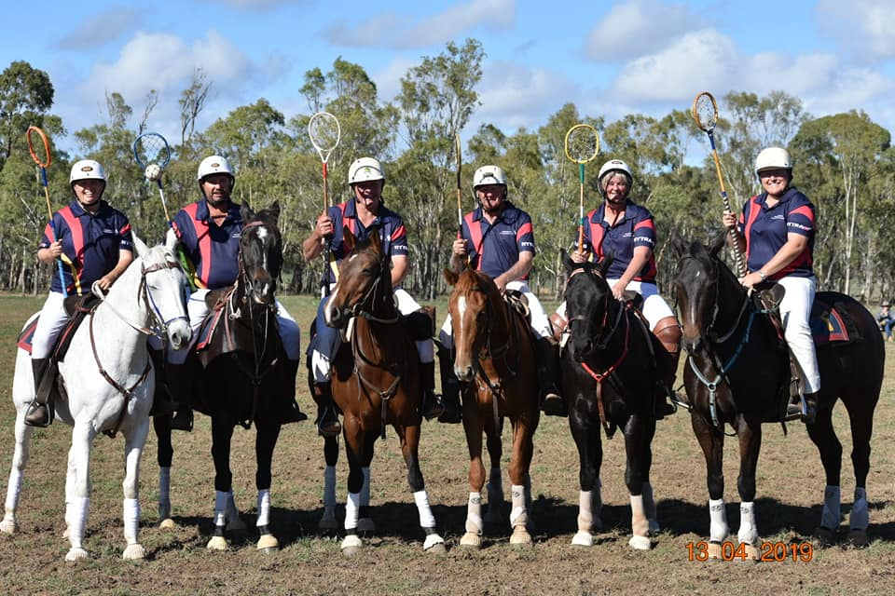
TOOWOOMBA POLOCROSSE CLUB
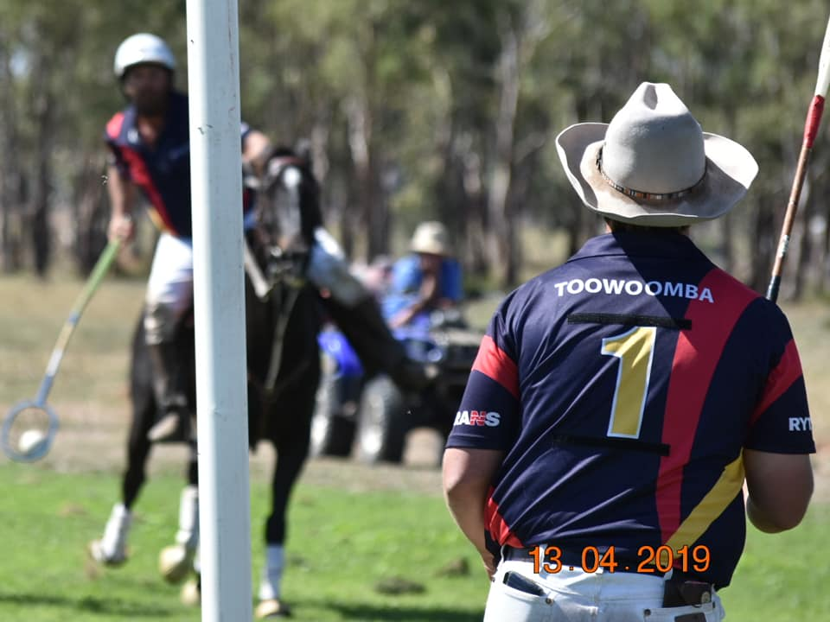
Celebrates 70 years in Polocrosse on
8th & 9th June 2019
FEES
Adult / Intermediate players - $25.00
Junior player - $5.00
Spectators - FREE
QPA Women's competitors will be covered by the QPA
COMPETITION
Play will commence at 8am Saturday and Sunday
Open, Juniors, Mini Juniors & Blue Bandage Competition.
Toowoomba Polocrosse is also hosting the QPA Women's competition (as per attached flyer)
LOCATION & YARDS
Oakey Showgrounds
Oakey Cooyar Road, Oakey
(Please note that the road between the top camping ground and bottom ground that run past the canteen area will be blocked off. Therefore please use the appropriate gates to access the correct areas. The Canteen area is a NO HORSE ZONE and allocated walkways / areas will be signed).
There are limited yards available
Powered sites
CANTEEN
Canteen will be running all weekend
Friday night sausage sizzle, gold coin donation
Saturday Night: 2 course dinner for $10.00 (Hot pots and Dessert)
Come along and help us celebrate our 70 years in Polocrosse with DJ Brando.
CLUB CONTACT
Nic Wills - M: 0431 561 205 - E: Toowoombapolox@outlook.com

SPECIAL CONDITIONS/ INFORMATION
1. NO DOGS PERMITTED ON GROUNDS as per PAA Ruling
2. RISK MANAGEMENT POLICY IN PLACE
3. AMBULANCE WILL BE IN ATTENDANCE
4. NO ELECTRIC TAPE as per PAA RULING
5. ALL A & B GRADE GAMES MUST HAVE TWO UMPIRES as per PAA Ruling
NOMINATIONS All team nominations must be done through the National Online Database
For any Database nomination problems: poloxqld@bigpond.net.au and 46323045
CLOSE OF NOMINATIONS: 9am Thursday 06th June 2019
HORSE HEALTH DECLARATIONS TO BE PROVIDED
PIC number QEJD0404

