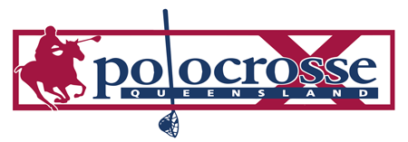
QPA Women's Competition
Toowoomba Carnival 8th & 9th June 2019
Guest Mentors: To be confirmed
All players are to nominate through the QPA Database
State - QLD Women's Competition
By Tuesday 04th June 2019
Teams will be announced on Friday night at the evening function at 6pm
(Held in the Greenwood Hall with drinks and cheese platters provided).
Enjoy a cocktail hour held on Saturday afternoon between 5:30pm and 6:30pm in the Greenwood Hall, along with grazing platters and guest speakers.
For any further information, please contact the QPA office (07) 46 323 045

